K L UNIVERSITY
FRESHMAN ENGINEERING DEPARTMENT

A Project Based Lab Report On

ERP-based student course registration system (ERP-SCRS)

SUBMITTED BY:

ID NUMBER NAME

2500032700 P. Chan Basha

UNDER THE ESTEEMED GUIDANCE OF
K SAI SANDEEP
ASSISTANT PROFESSOR



KL UNIVERSITY
Green fields, Vaddeswaram – 522 502 Guntur Dt., AP, India.

DEPARTMENT OF BASIC ENGINEERING SCIENCES - 1



CERTIFICATE

This is to certify that the project based laboratory report entitled “ERP-based student course registration system (ERP-SCRS)” submitted by P.Chan Basha, bearing Regd. No. 2500032700 to the Department of BES-1 , KL University in partial fulfillment of the requirements for the completion of a project based Laboratory in “PYTHON PROGRAMMING (25SC2007)” course in I B Tech II Semester, is a Bonafede record of the work carried out by him/her under my supervision during the academic year 2025 – 2026.

PROJECT SUPERVISOR HEAD OF THE DEPARTMENT Dr. K SAI SANDEEP Dr. D. HARITHA

ACKNOWLEDGEMENTS

It is great pleasure for me to express my gratitude to our honorable President.

Sri. Koneru Satyanarayana, for giving the opportunity and platform with facilities in accomplishing the project-based laboratory report.
I express sincere gratitude to our Director Dr. A. Jagdeesh for his administration towards our academic growth.
I express sincere gratitude to our Coordinator and HOD-BES-1 Dr. D. Haritha for her leadership and constant motivation provided in successful completion of our academic semester. I record it as my privilege to deeply thank you for providing us with the efficient faculty and facilities to make our ideas into reality.
I express my sincere thanks to our project supervisor K SAI SANDEEP for her novel association of ideas, encouragement, appreciation, and intellectual zeal which motivated us to venture this project successfully.
Finally, I am pleased to acknowledge our indebtedness to all those who devoted themselves directly or indirectly to making this project a success.

Name: P. Chan Basha

ID No: 2500032700

ABSTRACT

The ERP-based Student Course Registration System (ERP-SCRS) is developed to provide an efficient and automated solution for managing course registration processes in educational institutions. Traditional manual systems often lead to errors, delays, and inefficiencies in handling student course enrollment. This project addresses these challenges by implementing a digital platform that simplifies the registration process for both students and administrators.
The system allows students to create accounts, log in securely, view available courses, and register or drop courses based on their preferences. It ensures that course capacity is not exceeded by validating seat availability and prevents duplicate registrations. The administrator module enables the management of course details, including adding new courses and monitoring student enrollments.The application is developed using Python and incorporates Object-Oriented Programming principles to model real-world entities such as students and courses. Additionally, basic data analysis is performed using libraries like NumPy and Pandas to understand course demand, and visualization tools are used to represent the data graphically.
This system reduces manual workload, improves accuracy, and enhances the overall efficiency of course management. It serves as a foundational model that can be further extended into a full-scale ERP solution with advanced features such as database integration, graphical user interface, and enhanced security mechanisms.
Key Words: ERP, course registration, student management, automation, Python

INDEX

S.NO | TITLE | PAGE NO
1 | Introduction | 6
2 | Aim of the Project | 7
2.1 | Advantages & Disadvantages | 8
2.2 | Future Implementation | 8
3 | Software & Hardware Details | 9
4 | Data Flow Diagram | 10-11
5 | Algorithm for each module | 12
6 | Implementation | 13-15
7 | Integration and System Testing | 16-18
8 | Conclusion | 19

INTRODUCTION
The ERP-based Student Course Registration System (ERP-SCRS) is a software application developed to automate and simplify the process of course registration in educational institutions. In traditional systems, students manually register for courses, which often leads to errors, delays, and inefficiencies. This project aims to eliminate such issues by providing a digital platform where students can easily view available courses, register for them, and drop courses if needed.
The system provides a user-friendly interface for both students and administrators. Students can log in securely, check course availability, and perform registration operations. The administrator has the authority to manage course details such as adding new courses, updating capacities, and monitoring student enrollments.
This system ensures efficient handling of data, reduces manual workload, and improves accuracy in course allocation. It also introduces basic analytics to understand course demand and student preferences. Overall, the ERP-SCRS enhances the academic management process by making it faster, reliable, and more organized.
- Easy to learn
- Structured language
- It produces efficient programs.
- It can handle low-level activities.
- It can be compiled on a variety of computer

AIM
The primary aim of the ERP-based Student Course Registration System is to develop an efficient and automated platform that simplifies the process of course registration in educational institutions. The system is designed to provide a user-friendly interface through which students can securely log in, view available courses, and perform operations such as registering for and dropping courses based on their preferences. It ensures proper management of course data by maintaining accurate records of course capacity and student enrollment, while also preventing duplicate registrations and overbooking through validation mechanisms.
In addition to improving operational efficiency, the system aims to reduce manual effort and minimize errors associated with traditional registration methods. It also focuses on implementing fundamental software engineering principles such as Object-Oriented Programming and modular design to build a structured and scalable application. Furthermore, the project incorporates basic data analysis techniques to evaluate course demand and student choices, providing useful insights into academic trends. Overall, the system serves as a foundational ERP model that can be extended in the future with advanced features such as database integration, graphical user interfaces, and enhanced security mechanisms.

The modules in this project are -
→To provide an any time any place service for the customer.
→To minimize the number of staff at the ticket box.
→To promote the film on the internet.
→To increase the profit.

ADVANTAGES

- Reduces manual errors in course registration
- Saves time for both students and administration
- Provides real-time course availability
- Prevents over-enrollment using seat validation
- Easy to use and efficient system

DISADVANTAGES

- Requires basic technical knowledge to operate
- Data is not stored in a real database (limited scalability)
- Security features are basic (simple login system)
- System depends on correct user input

FUTURE IMPLEMENTATION
The current system can be further enhanced by adding advanced features. In future, the system can be connected to a real database such as MySQL for better data storage and security. A graphical user interface (GUI) can be developed to improve user interaction. Advanced authentication methods such as OTP-based login can be added for better security.
Additionally, features like timetable generation, conflict detection, and automated notifications can be integrated. Data analytics can be expanded using machine learning techniques to predict course demand and optimize resource allocation. These improvements will make the system more robust and suitable for real-world applications.

SYSTEM REQUIREMENTS

SOFTWARE REQUIREMENTS:

- Programming Language: Python
- Operating System: Windows 10 or above
- IDE: VS Code / PyCharm
- Libraries: NumPy, Pandas, Matplotlib

HARDWARE REQUIREMENTS:

- RAM: Minimum 4GB
- Processor: Intel i3 or above
- Storage: 500GB HDD/SSD
- Input Devices: Keyboard, Mouse

ALGORITHM

Step 1: Start the system
Step 2: Display main menu (Student/Admin/Exit)
Step 3: If Student selected → Login/Register
Step 4: Display student menu
Step 5: Select operation (View/Register/Drop)
Step 6: Check course availability and validation
Step 7: Update course and student data
Step 8: If Admin selected → Manage courses and view students
Step 9: Display results
Step 10: Exit system

IMPLEMENTATION

WEEK 1 – Python Basics
student_id = input("Enter ID: ")
name = input("Enter Name: ")
print(student_id, name)

WEEK 2 – Menu Using Loop
while True:
print("1.View 2.Exit")
ch = input()
if ch == "2":
break

WEEK 3 – Course List
courses = ["Python", "DSA", "DBMS"]
for c in courses:
print©

WEEK 4 – Functions
def show():
print("Courses")
show()

WEEK 5 – Dictionary
course = {
"code": "CS101",
"name": "Python"
}
print(course["name"])

WEEK 6 – OOP
class Student:
def __init__(self,name):
self.name = name
s = Student("Chan")
print(s.name)

WEEK 7 – Validation
registered = ["Python"]
if "Python" in registered:
print("Already Registered")

WEEK 8 – File Handling
with open("data.txt","w") as f:
f.write("Student Data")

WEEK 9 – Exception Handling
try:
x = int(input())
except:
print("Invalid Input")

WEEK 10 – NumPy
import numpy as np
a = np.array([10,20,30])
print(np.mean(a))

WEEK 11 – Pandas
I mport pandas as pd
df = pd.DataFrame({"Course":["Python"]})
print(df)

WEEK 12 – Matplotlib
import matplotlib.pyplot as plt
plt.bar(["Python"],[50])
plt.show()

import json
# ------------------ MODELS ------------------
class Course:
def __init__(self, code, name, capacity):
self.code = code
self.name = name
self.capacity = capacity
self.enrolled = 0
def has_seat(self):
return self.enrolled < self.capacity
def enroll(self):
if self.has_seat():
self.enrolled += 1
return True
return False
def drop(self):
if self.enrolled > 0:
self.enrolled -= 1

class Student:
def __init__(self, username, password):
self.username = username
self.password = password
self.courses = []
def register(self, course):
if course.code in self.courses:
print("Already registered")
return
if course.enroll():
self.courses.append(course.code)
print("Registered successfully")
else:
print("Course full")
def drop(self, course):
if course.code in self.courses:
self.courses.remove(course.code)
course.drop()
print("Dropped successfully")
else:
print("Not registered in this course")
# ------------------ DATA ------------------
courses = [
Course("CS101", "Python", 2),
Course("CS102", "DSA", 2),
Course("CS103", "DBMS", 2)
]
students = {}
# ------------------ LOGIN SYSTEM ------------------ #
def login():
print("\n1. Register\n2. Login")
ch = input("Enter choice: ")
if ch == "1":
u = input("Create username: ")
p = input("Create password: ")
students[u] = Student(u, p)
print("Account created")
return students[u]
elif ch == "2":
u = input("Username: ")
p = input("Password: ")
if u in students and students[u].password == p:
print("Login successful")
return students[u]
else:
print("Invalid login")
return None
# ------------------ STUDENT MENU ------------------
def student_menu(student):
while True:
print("\n--- STUDENT MENU ---")
print("1. View Courses")
print("2. Register Course")
print("3. Drop Course")
print("4. My Courses")
print("5. Logout")
ch = input("Enter choice: ")
if ch == "1":
for c in courses:
print(c.code, c.name, f"Seats: {c.capacity - c.enrolled}")
elif ch == "2":
code = input("Enter course code: ")
for c in courses:
if c.code == code:
student.register(c)
elif ch == "3":
code = input("Enter course code to drop: ")
for c in courses:
if c.code == code:
student.drop(c)
elif ch == "4":
print("Your Courses:", student.courses)
elif ch == "5":
break
# ------------------ ADMIN MENU ------------------
def admin_menu():
while True:
print("\n--- ADMIN PANEL ---")
print("1. Add Course")
print("2. View All Students")
print("3. Back")
ch = input("Enter choice: ")
if ch == "1":
code = input("Course code: ")
name = input("Course name: ")
cap = int(input("Capacity: "))
courses.append(Course(code, name, cap))
print("Course added")
elif ch == "2":
for s in students.values():
print(s.username, s.courses)
elif ch == "3":
break
# ------------------ MAIN ------------------
while True:
print("\n==== ERP SYSTEM ====")
print("1. Student Login")
print("2. Admin")
print("3. Exit")
ch = input("Enter choice: ")
if ch == "1":
student = login()
if student:
student_menu(student)
elif ch == "2":
admin_menu()
elif ch == "3":
break

15

14

INTEGRATION AND SYSTEM TESTING
OUTPUTS

Screen Shots:

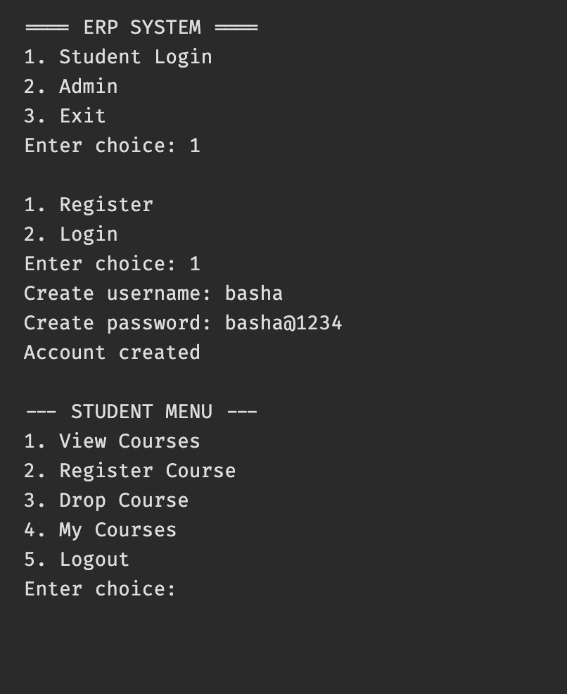

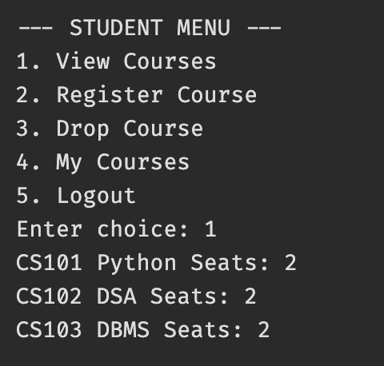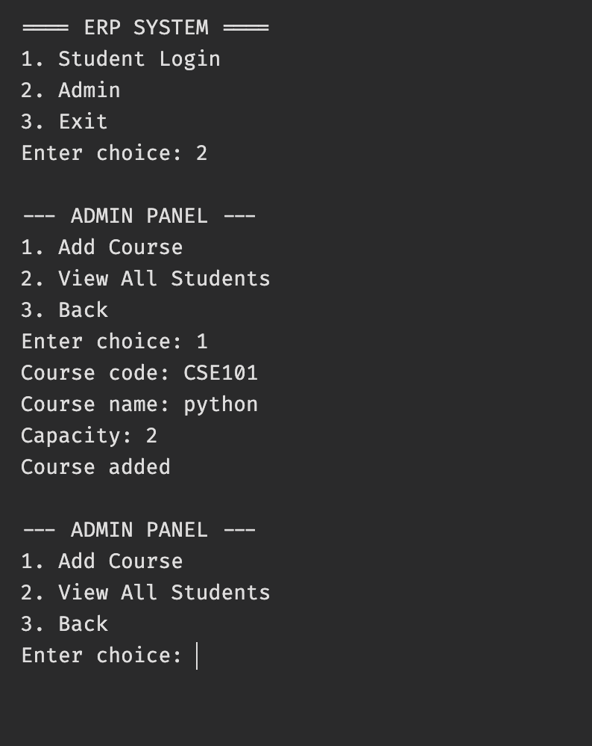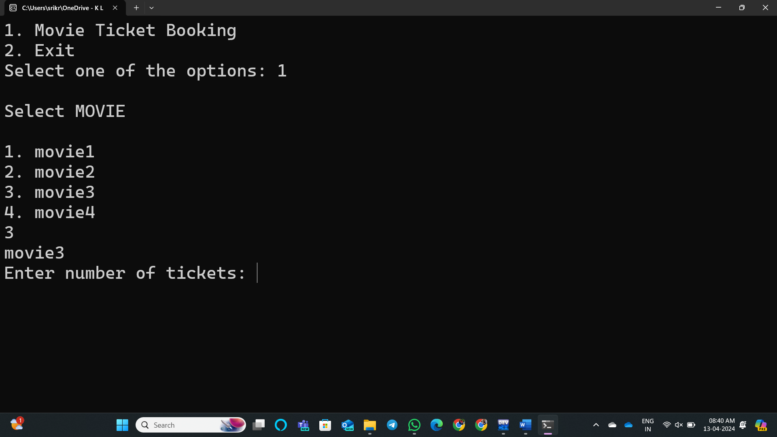

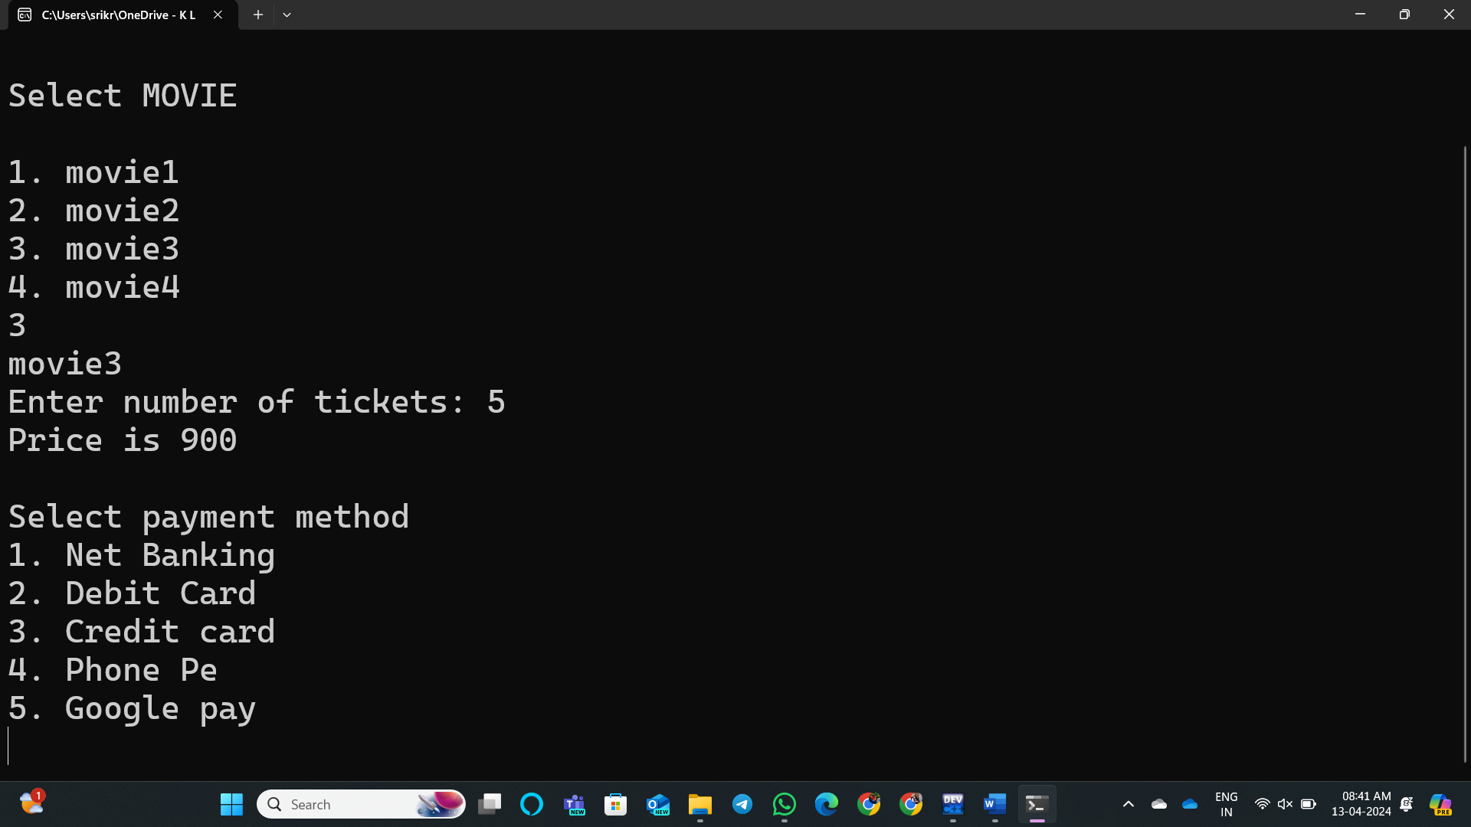

17

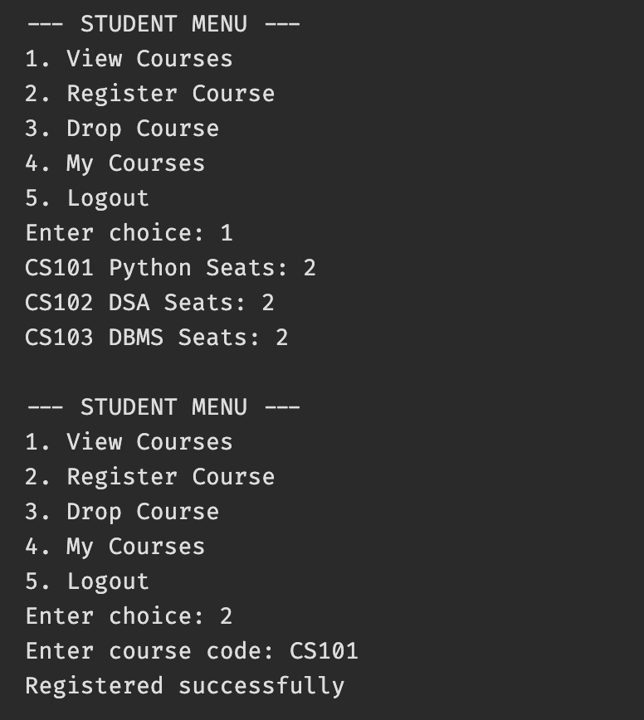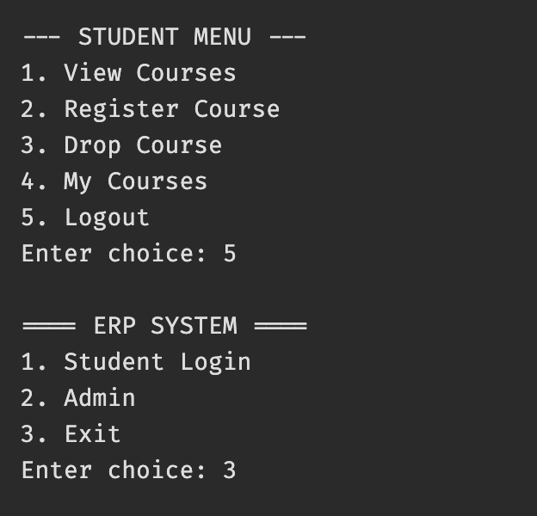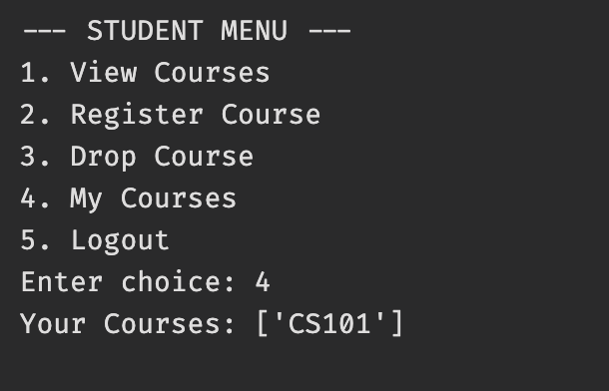
18

CONCLUSION
The ERP-based Student Course Registration System was successfully developed and tested. The system provides an efficient way to manage course registrations and reduces the workload of manual processes. It ensures accuracy, reliability, and ease of use for both students and administrators.
Although the system is basic, it demonstrates the core concepts of software development including data structures, object-oriented programming, and data analysis. With further improvements, the system can be expanded into a full-scale ERP solution used in real-world educational institutions.

19

